Woodhill Fallow Management Council 2026

Dear Successful Hunter
The Woodhill Fallow Management Council is pleased to advise you that you have drawn a hunting Block this year. The Block Number and Hunting Date are available on our website.
______________________________________________________________________________
Please read the accompanying information:
- Notice to Successful Primary Applicants and
- Rules of WFMC.

You, the primary applicant, are required to complete the following:
- Enter the Block Number, Hunting Date, and name, contact phone number and firearms licences for all members of the party (see page 2).
- Ensure that each member of the party has read and signed acceptance of the Indemnity Clause (see last page)
- Email the completed Permit Application, complete with signed Indemnity Clause Form, (that is, at least page 2 and the last page) along with scanned copy of Firearms Licences for each party member to the WFMC, by the 1st June 2026.
Email to: permits@wfmc.nz

Failure to complete the above or failure to send in copies of the signed Indemnity Clause Form and Firearms Licences or not paying the Permit fee, will result in no Permit being issued.
_______________________________________________________________________________
Payment of $200 by direct credit to:
Bank Account Number: 01-0141-0041658-00
With the following references:
Particulars: Surname (eg Smith)
Code: Date/Block (eg, 16 Aug B1)
_______________________________________________________________________________

If you have any questions please email permits@wfmc.nz (This email is not monitored daily)
ORANGE SAFETY VEST either Plain or Hi Vis
is compulsory for all members of party.
No vest, no hunt

__________________________________________________________________________
Woodhill Fallow Management Council
Permit Application for:
Hunting Block:
Hunting Date:
______________________________________________________________________________

Please complete the following information-
 | Primary Applicant Details – Can shoot either a Buck or Doe
Applicant Name: | «Name»
Firearms Licence No:
Expiry Date:
Contact Phone:

 | Companion 1 - Doe permit | Tick below for Buck
Applicant Name:
Firearms Licence No:
Expiry Date:
Contact Phone:

 | Companion 2 - Doe permit | Tick below for Buck
Applicant Name:
Firearms Licence No:
Expiry Date:
Contact Phone:

Observer (10yrs or over)
Applicant Name:
Contact Phone:

You are allowed a maximum of 4 people per block. ie. 3 hunters plus one observer, or 2 hunters & 2 observers (no more than 3 hunters) Observer must accompany one of the hunters at all times. They are not to shoot, there is no sharing of a rifle.

If you don’t wish to take up this opportunity, please email – permits@wfmc.nz
Do not shoot, Sorels, Spikers, Prickets or Weaner Bucks
Identify your target!

__________________________________________________________________________

1. NOTICE TO SUCCESSFUL PRIMARY APPLICANTS
__________________________________________________________________________
THINK SAFETY

WFMC would like to congratulate you on being successful in this year’s ballot. Enclosed is the Permit Application on which you must confirm you and your companions names and details, along with completion of the attached Indemnity Form signed by all parties by the 1st June in order to receive a hunting permit. Payment of $200 is required before issuing of permit. Permits and map of block are sent out 2-3 weeks before your hunt.

1 person – 1 hunt a year.

PLEASE ensure you and your companions are only on your list and have not been included in any other hunt. Any party where one or more are found to have doubled up (trying to get two or more hunts) will be disqualified. NO EXCEPTIONS.

FIREARMS LICENCES MUST BE VALID.

A COPY OF ALL FIREARMS LICENCES MUST ACCOMPANY YOUR RETURN. There is NO room for compromise on this. Bow hunters need a firearms license.

___________________________________________________________________

KILL RETURNS -
All kill returns received by October 1st 2026 will go in the draw for a $100 Hunting & Fishing Voucher

___________________________________________________________________

PERMITS -
- Allows management of deer numbers
- Primary Permit Holder is issued a permit for a Buck or Doe automatically and can take either a Buck or Doe, but is limited to one Deer.
- The other hunters in the party are issued a doe only permit but can apply for a buck only permit, tick the box next to your name.
- Accepting a buck permit excludes that person from taking a doe.
- Hunter must carry permit at all times during their hunt.
- Hunters 70yrs or older get a buck or Doe permit

COMPETITION - Bert Howlett Memorial Trophy

This trophy was created in recognition of the countless hours of service Bert gave to the Woodhill Fallow Management Committee. He was a foundation member in 1988 and was active until his death in 2007 at the age of 82

For best buck’s head for the year-

The following rules apply
- No conditions of the permit are to be breached by any member of the party
- The Bucks head is to be presented to WFMC duty patrol on day
- Heads will be assessed on the Douglas score- WFMC judgment will be final.

Prize: A voucher to the value of $150

__________________________________________________________________________

PLAIN orange vest is compulsory for all members of party.
No vest, no hunt
__________________________________________________________________________

Hunters – THINK SAFETY

IDENTIFY your TARGET. USE of binoculars is recommended.

Consider your FIRING ZONE – IF IN DOUBT, DO NOT FIRE.

There may be unauthorized Vehicles in the Forest, move to a position of safety if you see/hear a Vehicle or Motorbike approaching.

WFMC hunters have a 100% firearms safety record. Let’s keep it.

_____________________________________________________________________________
- RULES OF THE WOODHILL FALLOW MANAGEMENT COUNCIL
_____________________________________________________________________________

PLAIN ORANGE VEST to be worn at ALL times in forest

Woodhill Forest is primarily an Operational Production Forest. Please be aware that contact with forest operations is possible at any time, and that those operations take precedence over all other activities.

The following conditions apply:

- As a primary applicant having accepted this permit you agree to abide by the conditions that apply to this permit. You are responsible for your companion’s actions and that ALL MEMBERS OF THE PARTY ARE AWARE OF THESE RULES. As Primary applicant you must be in attendance on the day of your hunt. Any primary permit holder 70yrs or older must have at least one companion listed on their permit.

- Tasman Road gate opens at 6 am. Park your car at the access point indicated on the map, leave your block number clearly visible on the dash. If more than one vehicle, make copy of block number.

- Hunting is from daylight to dusk only. One firearm per hunter. Access/egress to and from blocks is permitted during dark hours. Do not load your firearm until you reach your block boundary. Access to block is by foot only.

- Firearms license to be carried at all times and produced when asked by patrol on the day.

- No Rim fire rifles, shotguns, dogs, spotlights, thermal or night vision equipment are permitted under any circumstances.

- No Black powder firearms or tracer ammunition allowed as they are considered a fire hazard.

- Bow hunters are NOT permitted to take firearms onto hunting blocks.

- A BUCK is defined as an animal with palmation. NO SOREL (2 year old Buck typically 8 points) SPIKERS, PRICKETS or WEANER BUCKS TO BE SHOT – IDENTIFY YOUR TARGET ! Buck permit holders - please refer to additional buck permit information at the bottom of this form.

- All pigs, possums, peacocks and hens can be shot within your block.

- No shooting of any other living thing is permitted.

- No indiscriminate firing of rifles permitted, i.e. no sighting in. This is an enclosed, managed deer hunting area. Target practice of any sort is banned. No shooting along or across block boundary roads.

- Consideration for hunters in adjoining blocks is to be shown at all times.

- No hunting under the influence of drugs or alcohol.

- The head of any deer shot (not pigs or possums) are to be taken to entry point and put in bin, your name should also be put with the head.

- If you have a Bucks head you wish to keep you MUST liaise with the duty person who will be periodically checking car parks.

- Members of the WFMC or deputies on gate duty have the right to routinely check carry bags and vehicles. Full co-operation with patrol personal is paramount.

- You as the permit holder must undertake on behalf of your party, on the form provided, return a record of kills and all deer sightings. ALL PRIMARY PERMIT HOLDERS MUST FILE A RETURN BY 1st OCTOBER.

- Forest owners have the right to close the forest at any time for Health & Safety reasons.

- Firearms must comply with the 2020 firearms law, no semiautomatics.

These conditions are laid down in the interests of the fallow deer herd and your safety. Failure to follow these conditions of your permit will result in a disqualification for you and/or your party from future ballots for a minimum period of one year.

_____________________________________________________________________________

Woodhill Fallow Management Committee & Ngā Maunga Whakahii o Kaipara

To comply with our lease obligations these rules also apply-
- NO smoking in forest.
- ALL vehicles are required to have a current WOF and registration when entering forest.
- NO camping in forest or access roads.

IN CASE OF FIRE OR EXTREMELY DANAGEROUS CONDITIONS EVACUATION OF FOREST MAY BE NECESSARY. ON HEARING SIREN SOUND IMMEDIATELY MAKE WAY TO YOUR CAR PARK AND WAIT FOR PATROL.
_____________________________________________________________________________

ARMS CODE – BASIC RULES
- Treat every firearm as loaded.
- Always point firearms in a safe direction.
- Load a firearm only when ready to fire.
- Identify your target.
- Check your firing zone.
- Store firearms and ammunition safely.
- Avoid alcohol or drugs when handling firearms.
_____________________________________________________________________________

PLAIN ORANGE VESTS ARE COMPULSORY

Additional Buck permit Information

Please take the time to understand this information.
If you have any questions, contact the WFMC.

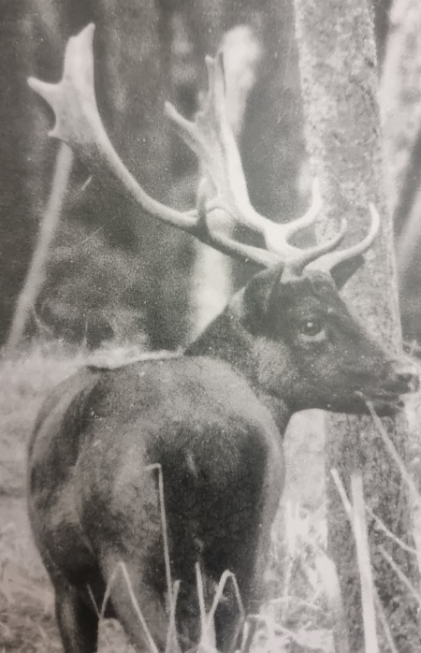 | 4+ year old Buck, the ideal trophy for Woodhill Forest. This is a shooter.  Note it is common to see Bucks with a split palm in Woodhill Forest, see below for further detail.
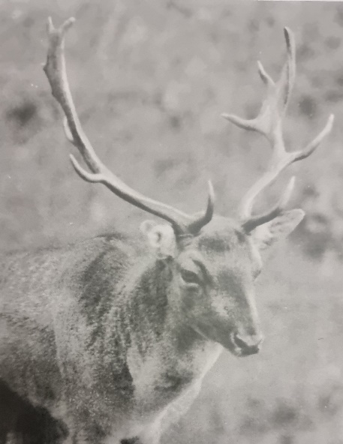 | 3-4 year-old Buck. This buck has had a chance to grow and is a good trophy for Woodhill Forest. This is a shooter.
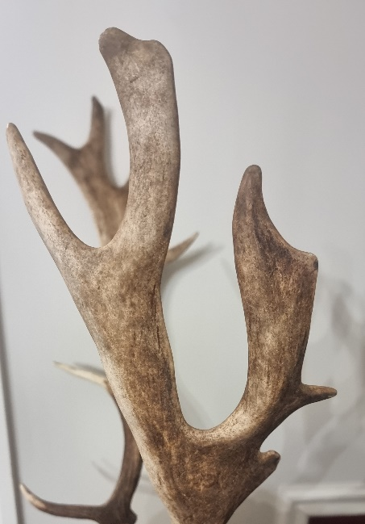 | Example of a Split Palm. This is a genetic defect and quite common in the Woodhill Fallow herd. This is ok to shoot.
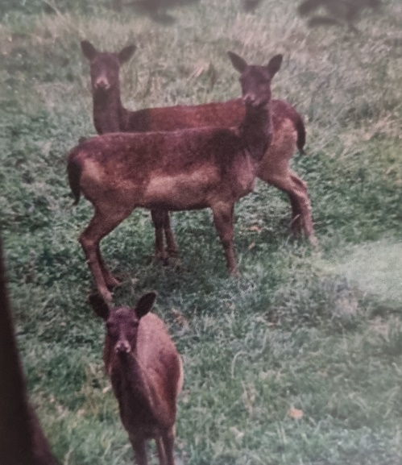 | Group of mature does, note the filled-out body and elongated (long) nose.  If you have a buck or a doe permit this is the perfect doe to take, remember only one animal per hunter. The Primary can choose a buck or a doe and that is the Primary Permit Holder’s choice to make during the day. A doe of any age can be harvested. Note no sign of a pizzle hanging down, even a Weaner buck with no antlers has a visible pizzle. Refer to below photos. This is a shooter!

BELOW THE LINE ARE NOT SHOOTERS

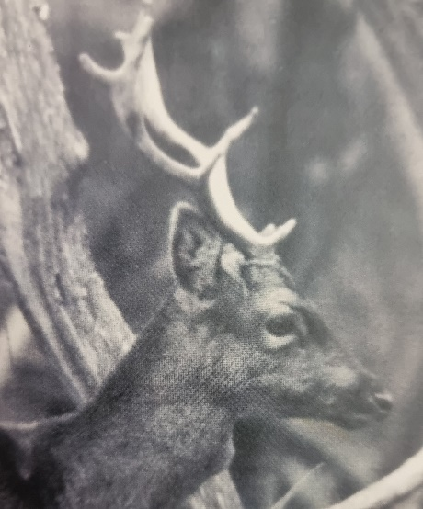 | A Sorel or 2-3 year-old Buck. Typically 8 points and no palmation, thin in the neck and generally hold themselves quite upright. Not a shooter!
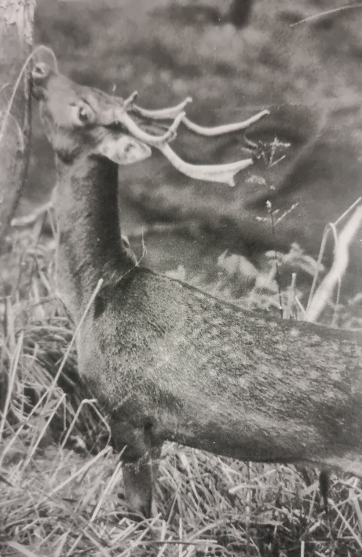 | Another example of a Sorel or 2-3 year-old Buck. Typically 8 points and no palmation, thin in the neck and generally hold themselves quite upright. This would commonly be this animal’s first head/set of antlers after being a spiker/pricket. Not a shooter!
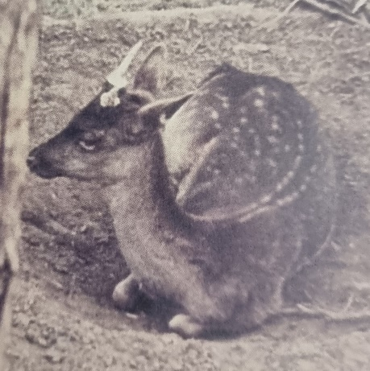 | An example of a Fallow Spiker.  Not a shooter!
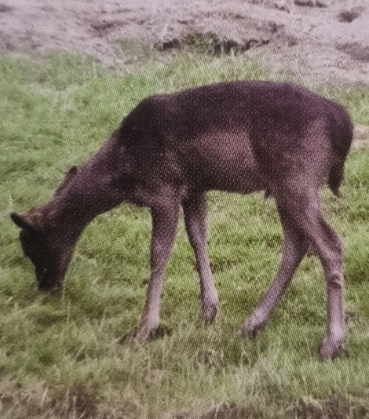 | Example of a Weaner Buck. Note the pizzle hanging down forward of the rear legs, also no antlers. Weaner Bucks generally do not form any sort of spikes or even soft nubs until they reach around 1 year old. The fur is usually visibly soft/fluffy and they have a small juvenile looking face and head. Not a shooter!
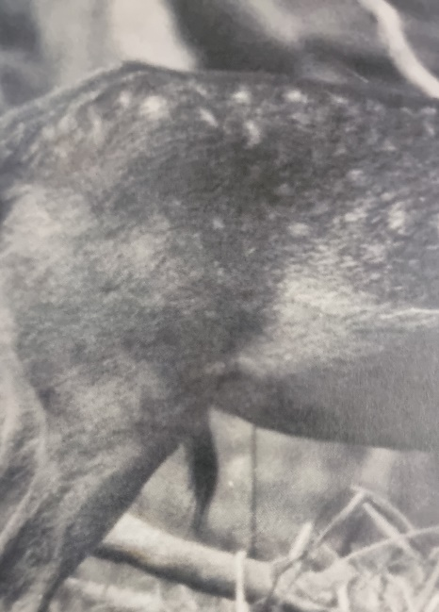 | An example of a visible Pizzle.  The pizzle is usually very visible when the animal is broadside.
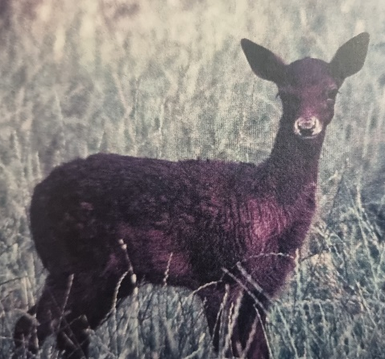 | Example of a Weaner Buck.  The pizzle is partially hidden by grass, note the juvenile face and fluffy looking body. Not a shooter!

_____________________________________________________________________________
WFMC Indemnity Form
_____________________________________________________________________________

Indemnity Clause: PLEASE READ

I understand that hunting is potentially dangerous and by signing this form I hold blameless members of the Woodhill Fallow Management Council, and Ngā Maunga Whakahii o Kaipara and any of their employees, associates or management for any accident, loss or misfortune that may befall me whilst in the Ngā Maunga Whakahii o Kaipara Woodhill Forest.

I also acknowledge I will abide by legislation relating to the use of firearms, and the rules for Ballot hunting as set by the Woodhill Fallow Management Council Inc.

Signed Primary Hunter: ……….…………………………… Date: …………………

Signed 1st Companion: ……….……………………………. Date: …………………

Signed 2nd Companion: ……….……………………….…… Date: …………………

Signed Observer: ……………………………………………. Date: …………………
Observer must accompany one of the hunters at all times. They are not to shoot, there is no sharing of a rifle.

Please ensure all companions have signed the Indemnity Clause, then attach this with your Permit Application and send back to permits@wfmc.nz along with scanned copies of all companions Firearms Licenses by June 1st 2026

